DICE GAME DESIGN AND ALGORITHM

The image below shows the first design I sketched for the dice game. At first, many other ideas came to my mind but I ended using the design below. At this stage, I haven’t decided which colours I was going to use.

**Sketches/Designs**

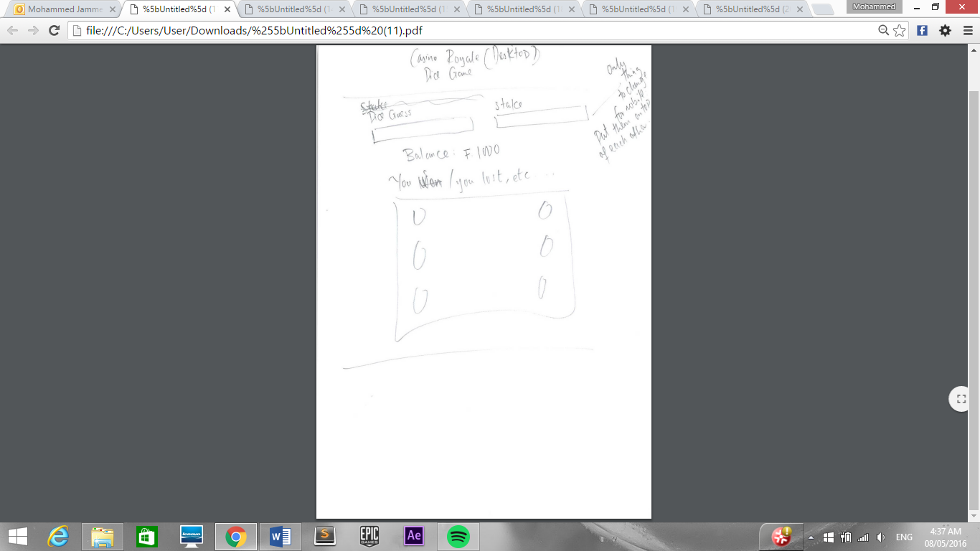

Before actually building the game, I decided to redesign the page. If you compare the screenshow below and the one above, you will only notice small difference. This is because I only made changes to my first design right before I started implementing it.

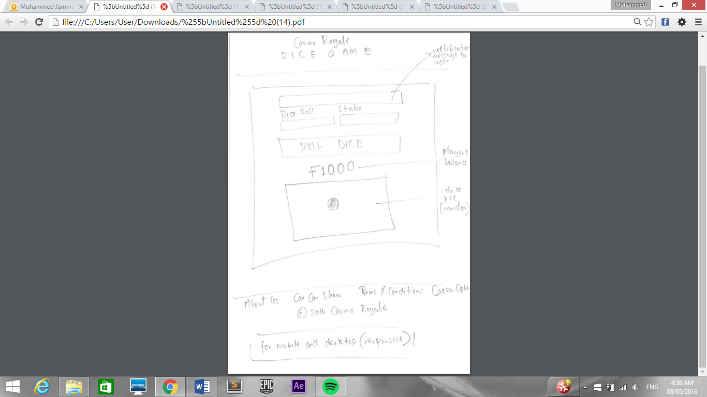

**Pseudo Code (1)**

After designing the site, I began writing the pseudo code for the game. As you can see below, there are many key points that are missing. However, it was a great starting point for me because I had a rough idea how to start developing the game.

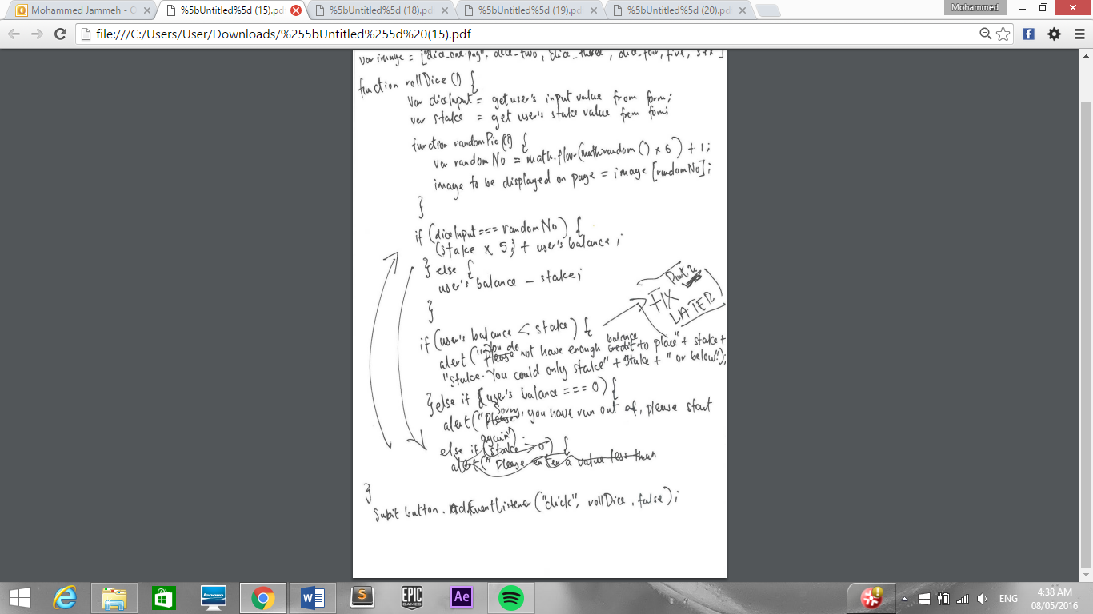

**Algorithm**

Despite my pseudo code being quite poor, it really helped me to write an algorithm for the game. If you observe carefully, you will notice the algorithm is much better and improved compared to the pseudo code. Additionally, it considers more possible exceptions.

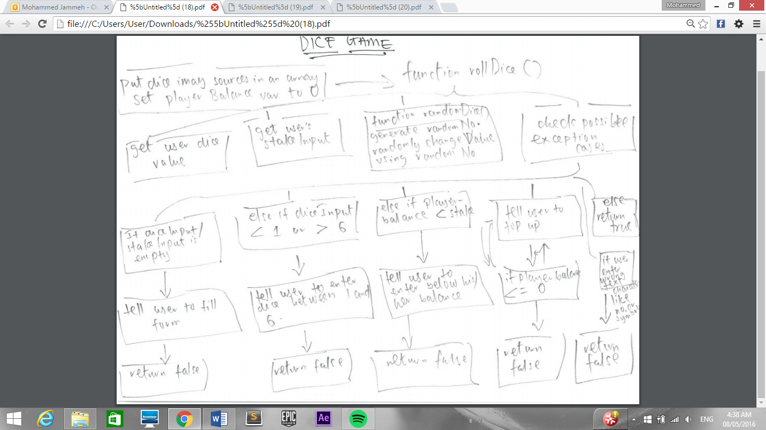

The top, centred box is meant to say “(if randomNumber === diceInput)”

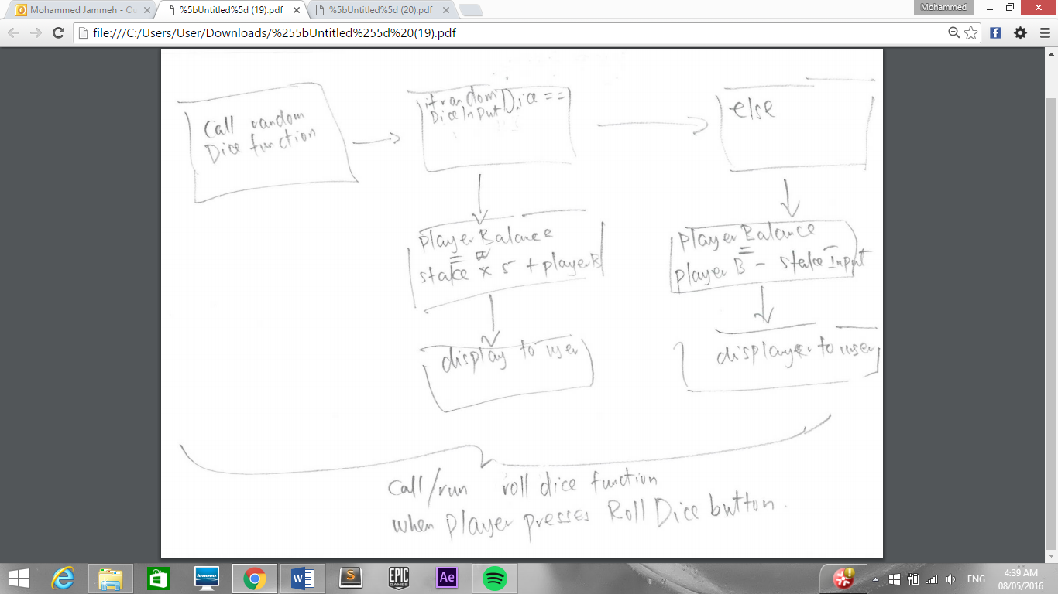

**Pseudo Code (2)**

After writing the algorithm for game, I decided to re-write my pseudo code so that it will be easier to actually write the code. My second pseudo code has included the possible exception cases value, for example, what will happen when a user enters a letter or other characters instead of numbers.

Whilst I was programming the game, more possible cases came to my mind which have not been included in the pseudo code or algorithm. However, they are part of the final implementation of the game.

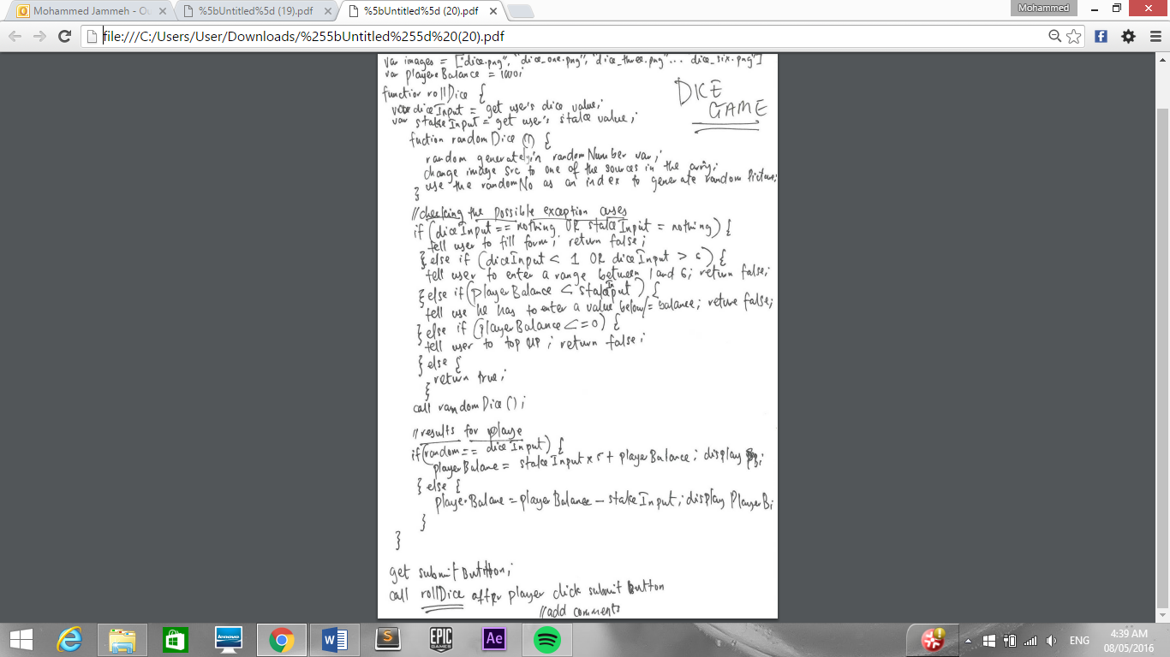

**Screen Design**

The image below is a screen design for the Dice Game page. Unfortunately, I created the screen design late; I designed it whilst building the site as I was not sure which colours to use for the website. In the end, it was successful; it helped to choose colours from Adobe Illustrator and apply them to the web page.

